**Solution:**

1.We choose **1980** as year

2.We select **Europe** as continent and we get the following result

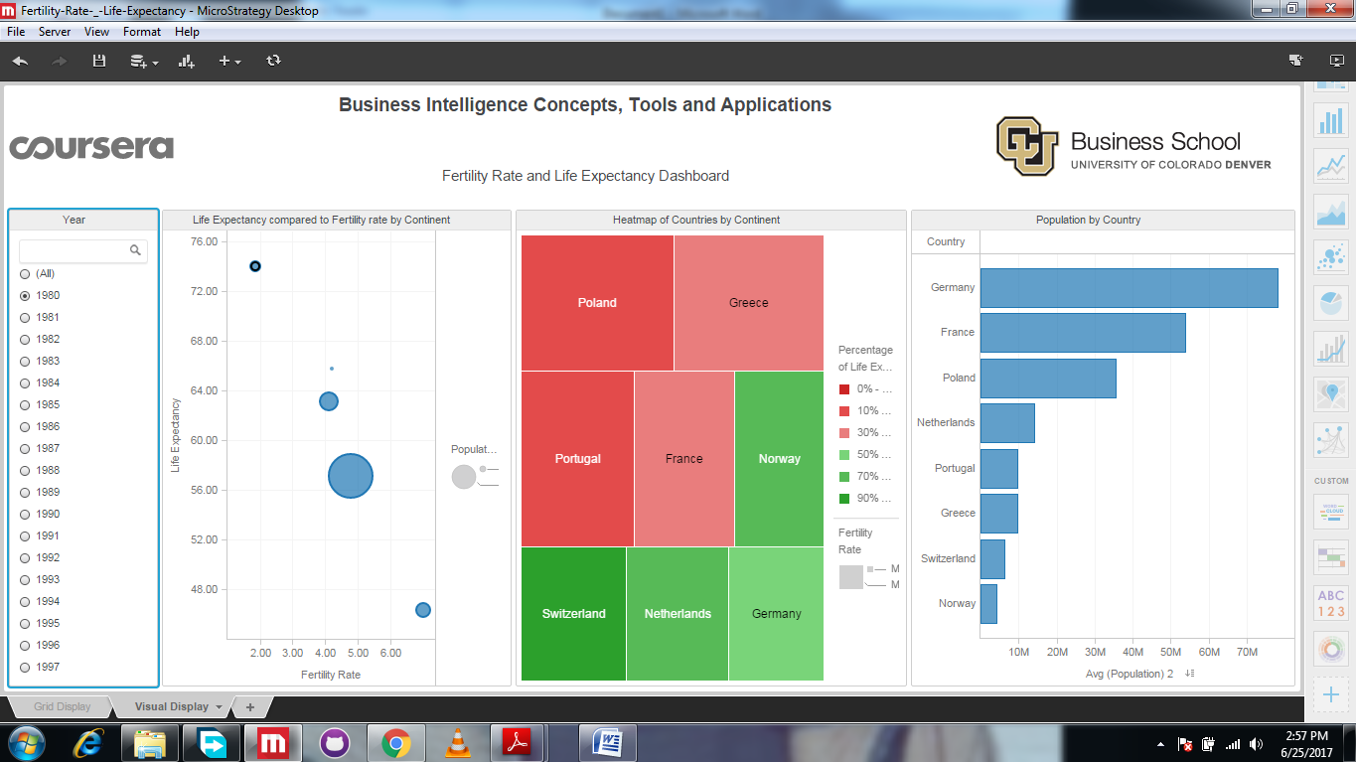

3.Then we choose **2007** as year to obtain following result

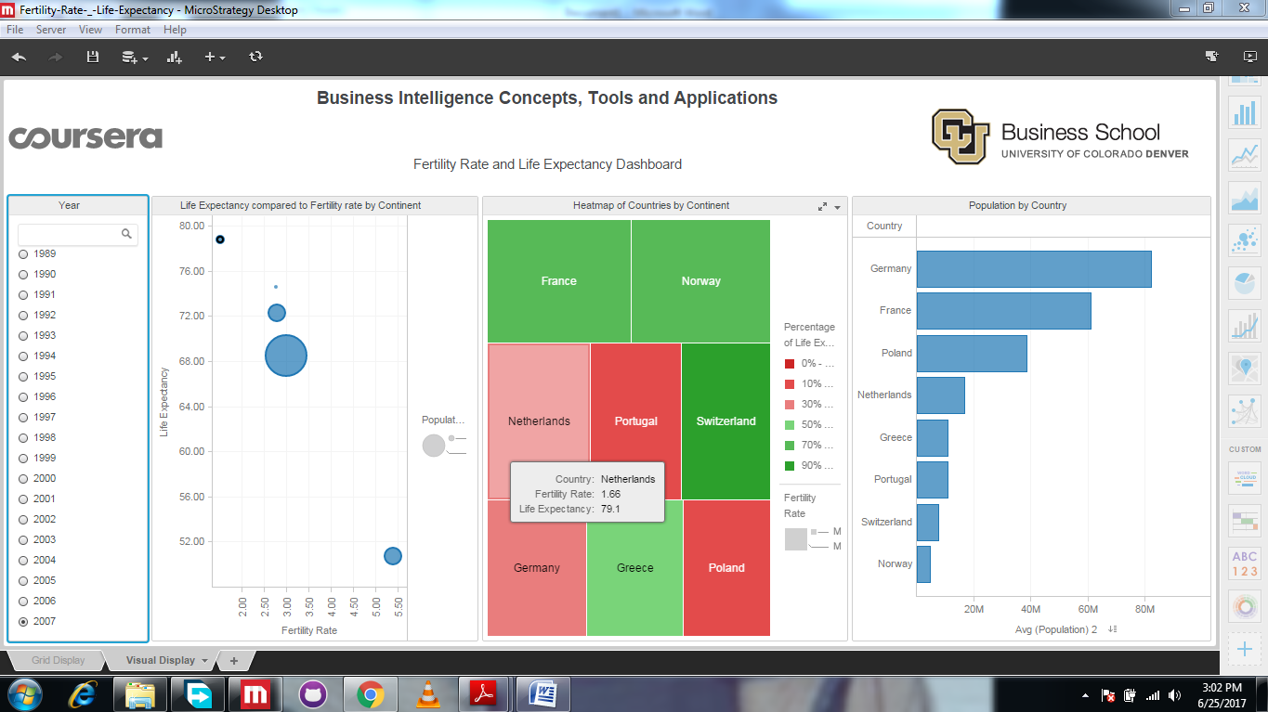

From the screenshots provided, it is very clear that **Poland** is the country in Europe which had highest fertility rate in 1980 and lowest fertility rate in 2007.